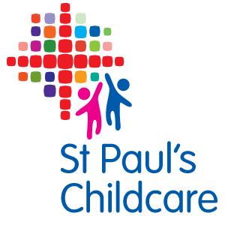
Behaviour Management Policy
At St Paul’s Childcare we believe that children flourish best when they know how they and others are expected to behave. Children gain respect through interaction with caring adults who act as good role models, show them respect and value their individual personalities. St Paul’s Childcare actively promotes British values and encourages and praises positive, caring and polite behaviour at all times and provides an environment where children learn to respect themselves, other people and their surroundings.

- Adults (staff, parents, carers, visitors) are always positive models who encourage desirable behaviour in children, such as kindness, caring and willingness to share.

- All staff are aware of the impact that the use of threatening language and aggressive tone has on children's wellbeing - any form of this will not be tolerated.

- Our setting takes positive steps to avoid a situation in which a child receives adult attention only in return for undesirable behaviour.

- Physical punishment, such as smacking or shaking, is neither used nor threatened. Such behaviour from any member of staff would be classed as gross misconduct.

- Children who misbehave will be encouraged to discuss class rules with a suitable member of staff in a manner that is age appropriate. The adult will seek to help them understand the unacceptability of their behaviour. It will be made clear that it is the behaviour - not the child - which is unwelcome, taking into account their age and stage of development; e.g. by distraction or withdrawing the child from the situation.

- Any behaviour problems will be handled in a manner appropriate to the child’s level of understanding and maturity.

- Any recurring behaviour problems are handled sensitively in conjunction with the parent/carer. We use observation records to help us to understand the possible cause of the behaviour and discuss with parents strategies to ensure a consistent approach is used, and continued support is offered.

- Adults are aware that some behaviours displayed may arise from a child’s special needs or individual circumstances. In those situations, support and advice will be sought from the child’s health visitor and any other relevant agencies and professionals, only after parental permission has been given.

- The designated officer is expected to be fully up to date with current good practice with regard to behaviour management issues. It is there responsibility to share information with other staff members as is appropriate and to support them in their care of the children.

- Where children are in an immediate risk of injury to themselves or others, distraction techniques are used. Positive handling should only be used when all other strategies, which do not employ force, have been tried and found unsuccessful or in an emergency situation. See Positive Handling policy.

- The matter is then referred to the Behaviour Management Officer who will discuss the incident and take further action as necessary. Any incidences where this is necessary will be recorded in the incident book and signed by a witness and then discussed with the parent before signature.

- Where behavioural issues occur with children who attend other providers; conversations, discussions and decisions, where possible and appropriate, will be shared with all concerned.

Lead Behaviour Management Officer: Joanne Smith
Amended 24th January 2022
Next review date: November 26

Signed:

Date:

